**Report of the website development.**

**1. Executive Summary:**

1. Initial Planning (March 3 - March 7):

* Gather your group members and discuss the assignment requirements in detail.
* Divide tasks among group members based on individual strengths and skills.
* Create a rough outline or wireframe of the website to visualize its structure and navigation.

2. HTML Structure (March 8 - March 14):

* Begin coding the HTML structure for each of the five interlinked pages.
* Focus on creating clean, semantic HTML that accurately represents the content of each page.
* Make sure to include proper headings, paragraphs, lists, and other structural elements as necessary.
* Incorporate placeholder text or content if actual content is not available yet.

3. CSS Styling (March 15 - March 21):

* Start working on the CSS style sheets for your website.
* Define styles for typography, colours, backgrounds, layout, and any other visual aspects of the website.
* Use CSS selectors efficiently to apply styles to different elements of your HTML pages.
* Ensure consistency in design across all pages of the website.

4. Content and Media (March 22 - March 28):

* Gather and/or create the content for each page of the website, including text, images, and other multimedia elements.
* Optimize images for web display to ensure fast loading times.
* Embed photos and other media into your HTML pages using appropriate HTML tags.

5. Testing and Debugging (March 29 - April 3):

* Test your website across different web browsers and devices to ensure compatibility and responsiveness.
* Validate your HTML and CSS code to catch any syntax errors or issues.
* Debug any layout or styling issues that arise during testing.
* Solicit feedback from peers or instructors to identify areas for improvement.

6. Final Touches (April 4 - April 11):

* Make any final adjustments or refinements to your website based on feedback and testing results.
* Double-check that all interlinking between pages works correctly.
* Ensure that the website is accessible to users with disabilities by implementing appropriate accessibility features.
* Prepare documentation or instructions for submitting the assignment.

7. Submission (April 12):

* Package all necessary files (HTML, CSS, images, etc.) into a zip file or another format specified by your instructor.
* Submit the completed website according to the instructions provided by your instructor, making sure to meet the deadline.
* Throughout the process, communication and collaboration within your group will be crucial for success. Regularly check in with each other to track progress, address any challenges, and ensure that everyone is on the same page. Good luck with your assignment!

**2. Project Goals:**

* Clarity: For each and every member of the team to learn designing, coding web pages.
* Measurable: Each member of the team is able to produce webpages, style sheets and lay out of each page.
* Achievable: Build the website, validate the html and CSS pages. Write report
* Relevant: The goal is for everyone to become proficient in website building.
* Time-bound: The constraint is the time of submission.
* To achieve all this, we have decided to each produce the whole website and pay particular attention to the page we were allocated.

**3. Scope of Work:**

* Design:
  + Completed: The design phase may involve creating wireframes, mock-ups, and visual designs for the website. This could include defining the layout, colour scheme, typography, and overall aesthetic.
  + Pending: Finalizing the design based on discussion on 08 April 2028. This may involve making revisions, refining visual elements, and ensuring consistency across different pages and screen sizes.
* Content:
  + Completed: Content creation involves writing or sourcing text, images, videos, and other media assets for the website. This includes product descriptions, service information, About Us page, etc.
  + Pending: Reviewing and finalizing content for accuracy, relevance, and alignment with the organization's brand voice and messaging. This may also involve optimizing content for SEO and ensuring it is formatted correctly for web display.
* Functionality:
  + Completed: Functionality development involves implementing features and interactive elements such as navigation menus, forms, search functionality, user authentication, e-commerce functionality (if applicable), etc.
  + Pending: Testing and refining functionality to ensure it works as intended across different devices, browsers, and user scenarios. This may involve fixing bugs, optimizing performance, and enhancing usability based on user feedback.
* Testing:
  + Completed: Testing involves various types such as usability testing, cross-browser testing, responsive testing, performance testing, security testing, etc. It ensures that the website meets quality standards and performs well under different conditions.
  + Pending: Conducting final rounds of testing to identify and address any issues or bugs discovered during testing. This may involve regression testing to ensure that fixes or changes haven't introduced new problems.
  + In summary:
  + Design: Pending finalization based on feedback.
  + Content: Pending review and optimization.
  + Functionality: Pending testing and refinement.
  + Testing: Pending final rounds of testing and bug fixes.

**4. Progress Update:**

* We have to complete the project by 11:59 PM on 12 April 2024

**5. Challenges and Solutions:**

* Compatibility Issues: As mentioned earlier, compatibility issues with older browsers and devices were a significant obstacle. This obstacle was addressed by:
  + Conducting thorough testing across various browsers and devices during the development phase to identify compatibility issues early on.
  + Implementing progressive enhancement and graceful degradation techniques to ensure that the website functions adequately across a wide range of platforms.
  + Utilizing polypills or alternative solutions to provide support for features not natively supported by older browsers.
  + Communicating with stakeholders about the importance of prioritizing modern browsers and devices for the best user experience while providing fallback options for older ones.
* Scope Creep: Scope creep, or the gradual expansion of project scope beyond its original boundaries, was another obstacle faced during development. This was addressed by:
  + Regularly revisiting the project scope and objectives to ensure alignment with the agreed-upon requirements and priorities.
  + Implementing change management processes to assess the impact of proposed changes on the project timeline, budget, and resources.
  + Communicating with stakeholders about the implications of scope changes and negotiating adjustments as needed to maintain project feasibility.
  + Documenting any scope changes and obtaining formal approval from stakeholders before proceeding with implementation.
* Resource Constraints: Limited availability of resources, such as developers, designers, or content creators, posed challenges during development. This obstacle was addressed by:
  + Prioritizing tasks based on their criticality and dependencies to optimize resource utilization.
  + Identifying opportunities for outsourcing or contracting additional resources to supplement in-house capabilities.
  + Implementing task prioritization and workload balancing strategies to ensure that resources are allocated effectively.
  + Providing additional training or support to team members to enhance their skills and productivity.
* Technical Challenges: Various technical challenges, such as performance bottlenecks, security vulnerabilities, or integration complexities, were encountered during development. These challenges were addressed by:
  + Collaborating with subject matter tutor.
  + Validating of each html page through W3CValidator for HTML and CSS
  + Checking to see how they look in different browsers.

**6. Budget Overview:**

* We do not have a budget as we are doing a class assignment.

**7. Next Steps:**

* Submission on 12 April 2024 before 11:59 PM

This website project is a group project. Building this has given us technical skills, communication skills, testing skills and finally the satisfaction of being able to achieve the desired effect. Building a website as a group can indeed provide a rich learning opportunity and a sense of accomplishment. Here are a few points to consider expanding on when reflecting on your project:

Technical Skills: What specific technical skills did you and your group members develop throughout the project? This could include programming languages, web development frameworks, design principles, version control systems, etc.

Communication Skills: Describe how communication played a crucial role in the success of your project. How did you communicate effectively with your team members to coordinate tasks, share ideas, and resolve conflicts? Did you utilize any particular communication tools or strategies?

Testing Skills: Discuss the importance of testing in the development process. What types of testing did you perform on your website (e.g., unit testing, integration testing, user acceptance testing)? How did testing contribute to the overall quality and reliability of your project?

Achieving the Desired Effect: Explain what the desired effect or goal of your website project was. How did you define success for the project? Did you encounter any challenges or obstacles along the way, and if so, how did you overcome them to achieve your desired outcome?

Satisfaction and Reflection: Reflect on your overall experience working on the project. What aspects of the project are you most proud of? What lessons did you learn that you can apply to future projects or endeavours?

**Screen shots of all the HTML validations**

index.html

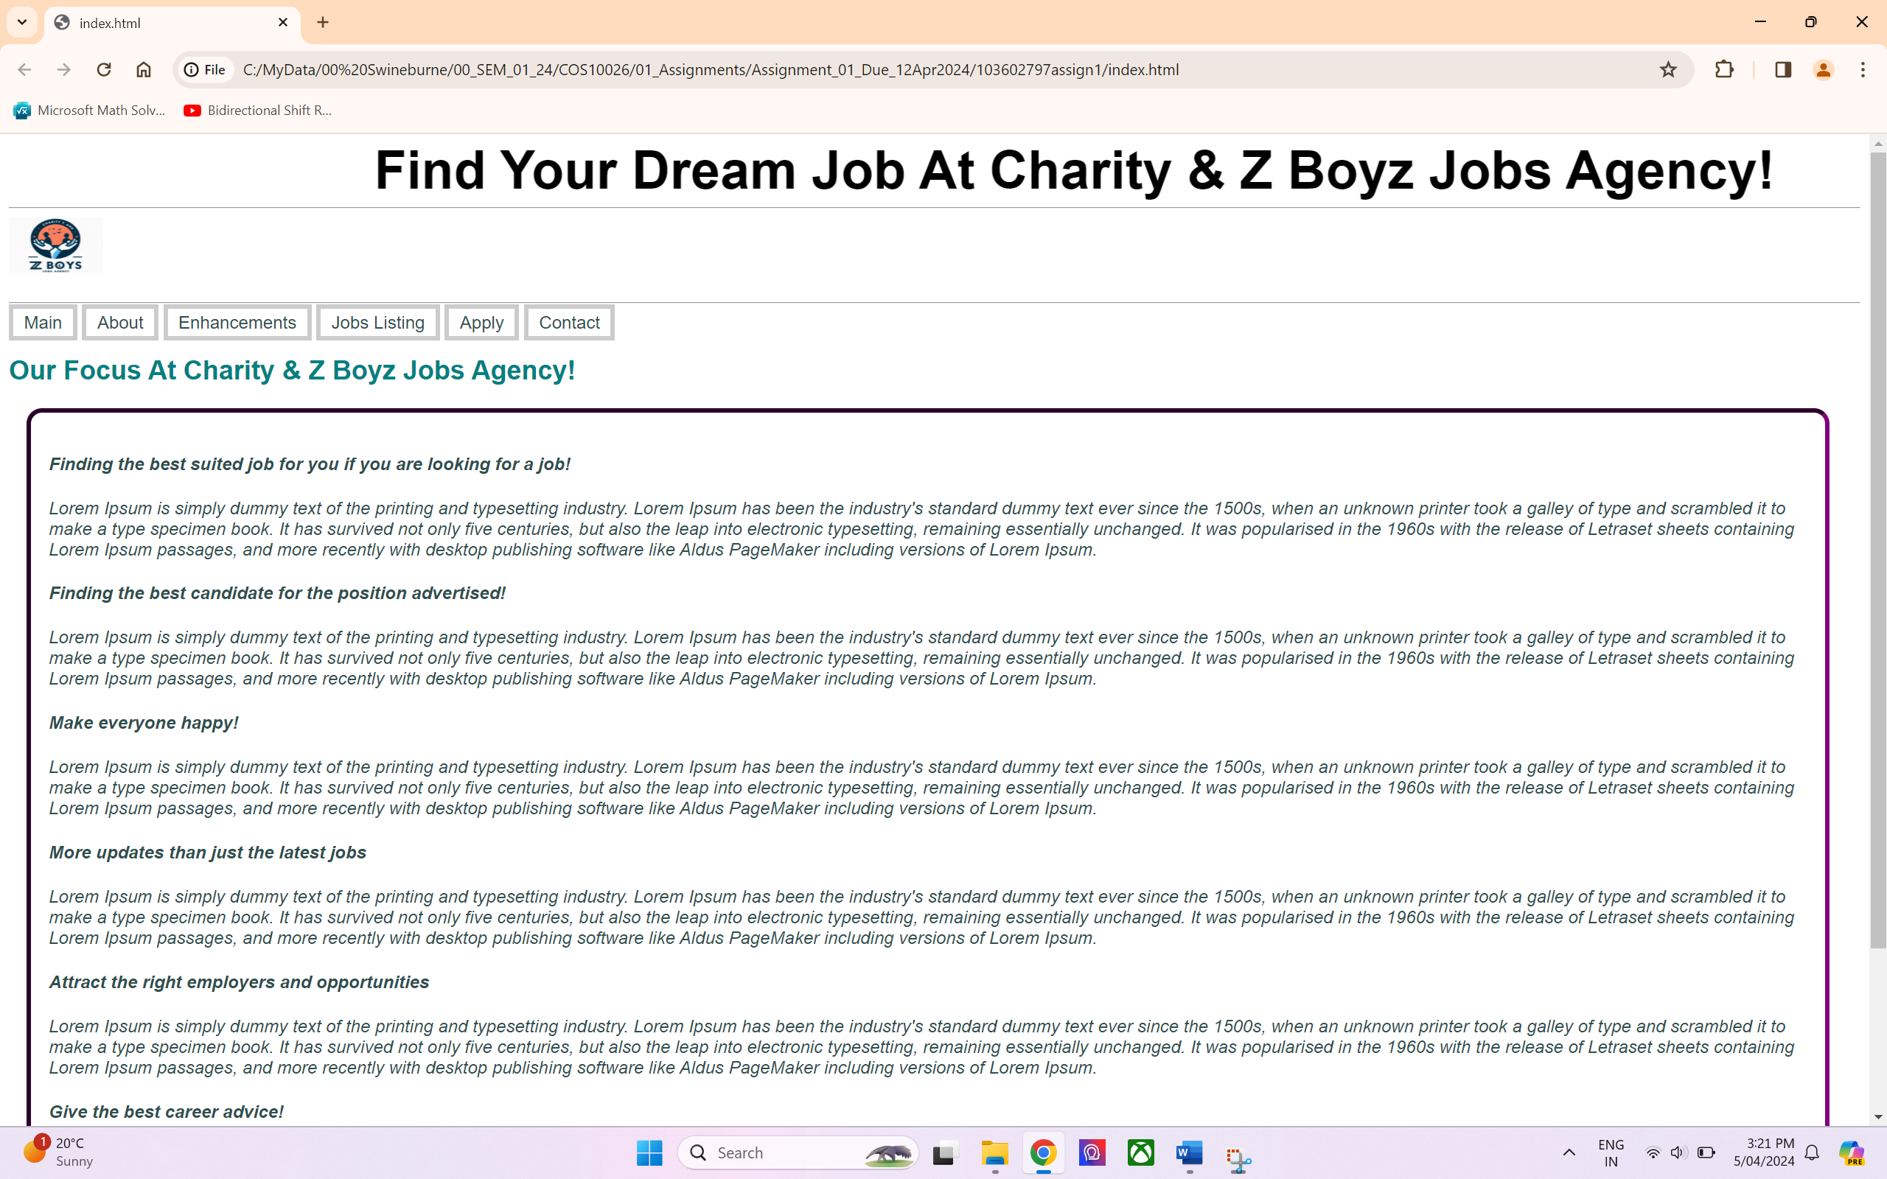

about.html

apply.html

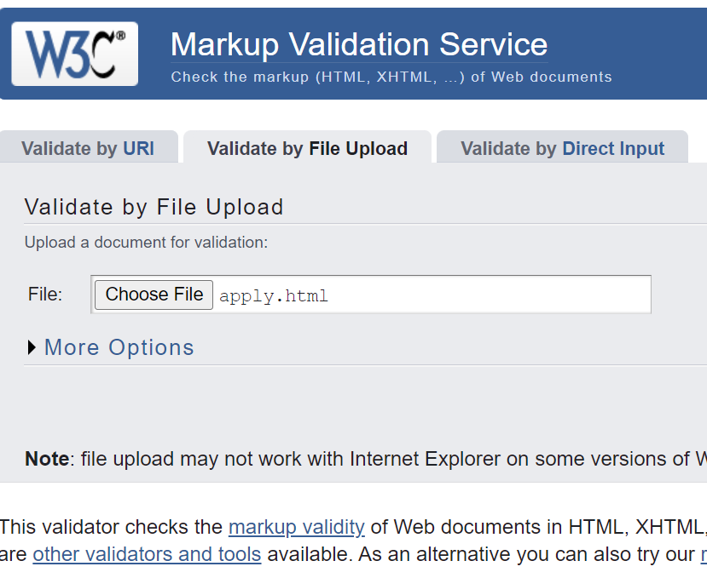

enhancements.html

jobs.html

A1234.html

B2345.html

H1234.html

J1234.html

**Screen shots of all the CSS validations**

**103602797dl.css**

103602797layout.css

103602797main.css

103602797marquee.css

103602797responsive.css

When I applied for the job on jobs.html

